# Diabetes_Prediction_web_app

Anaconda Environments 🡪 MachineLearning 🡪 Open Terminal

streamlit run "E:\Journey\My DS\Project 10 - Deploy Machine Learning Model using Streamlit in Python ML model Deployment\Diabetes Prediction web app.py"

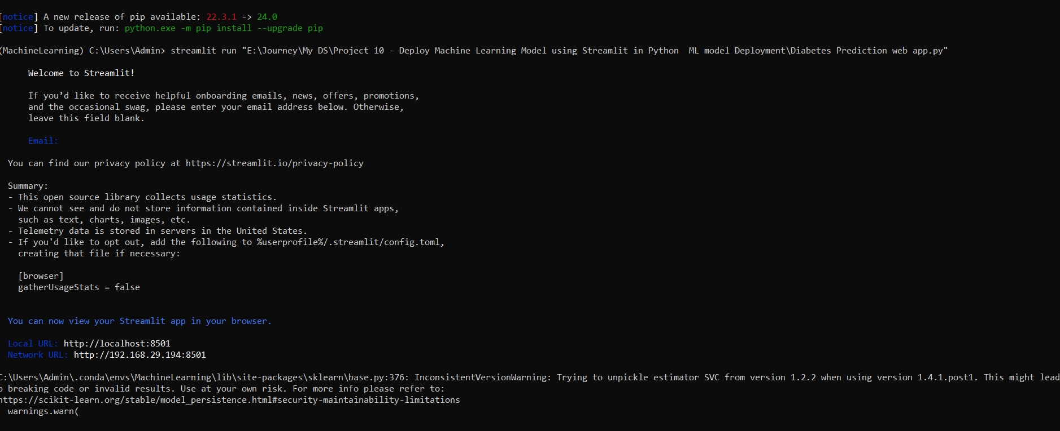

[Diabetes_Prediction_web_app · Streamlit](http://localhost:8501/)

You can now view your Streamlit app in your browser.

Local URL: http://localhost:8501

Network URL: <http://192.168.29.194:8501>

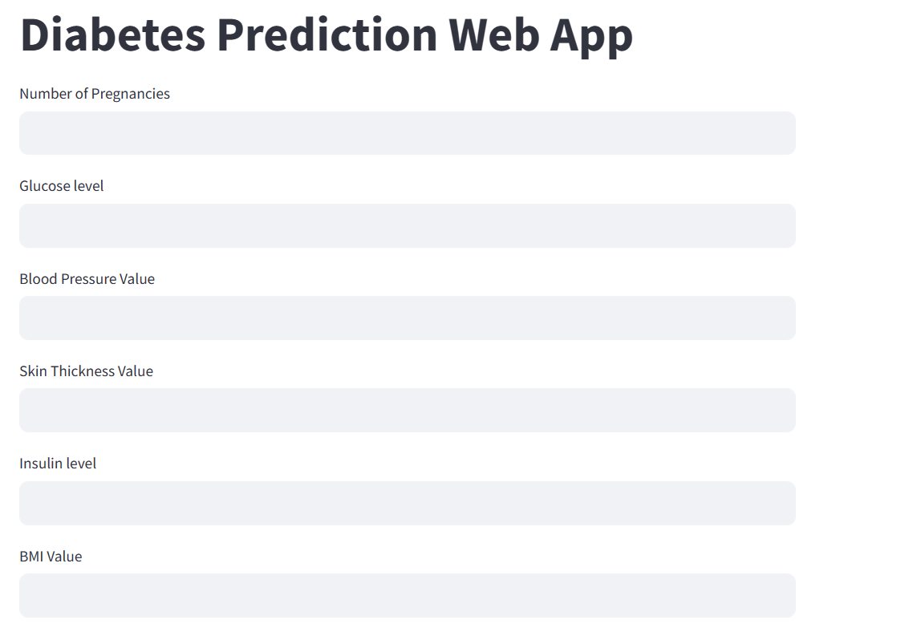

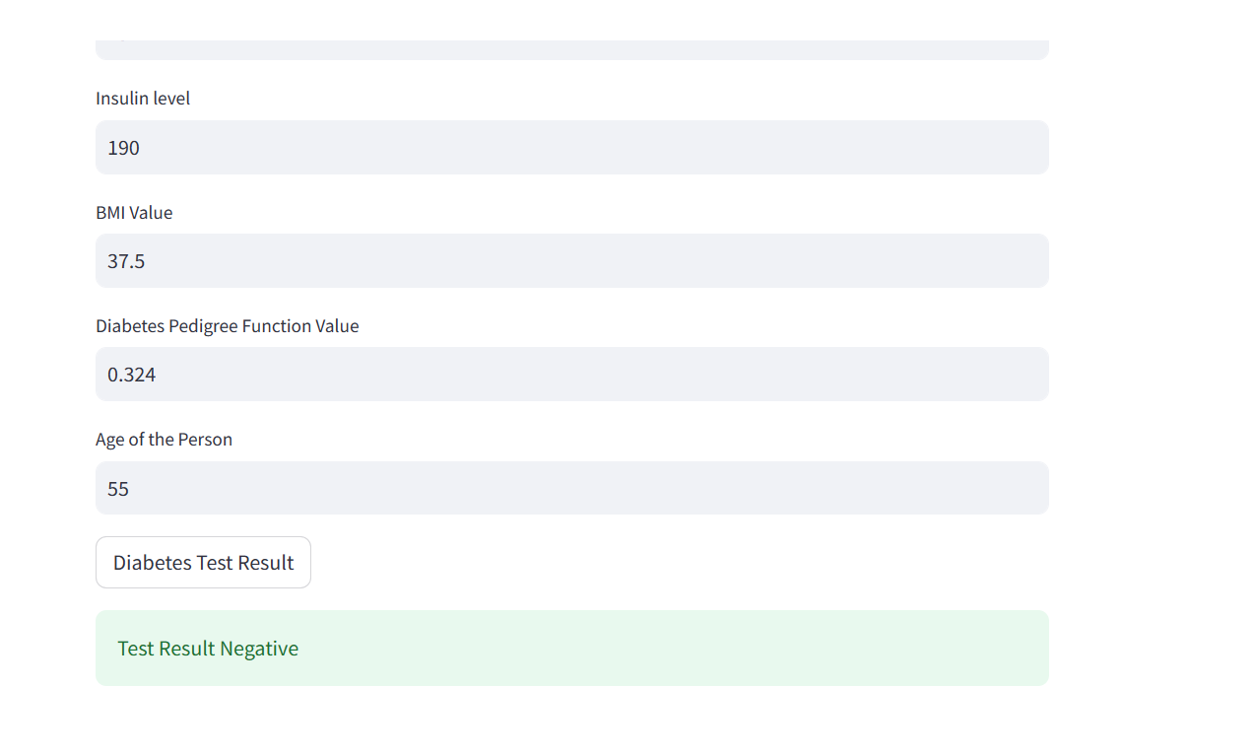

[Diabetes Prediction Web App.pdf](Diabetes%20Prediction%20Web%20App.pdf)